OPERATING Systems

**Name: Girish S Roll No.: AM.EN.U4AIE22044**

--------------------------------------------------------------------------

1. **Write a C Program that allows communication between parent and child process using ordinary pipes. The child should take an input (a String) from the user and supply it to the parent and the parent should change it to a string in uppercase and print it there.**

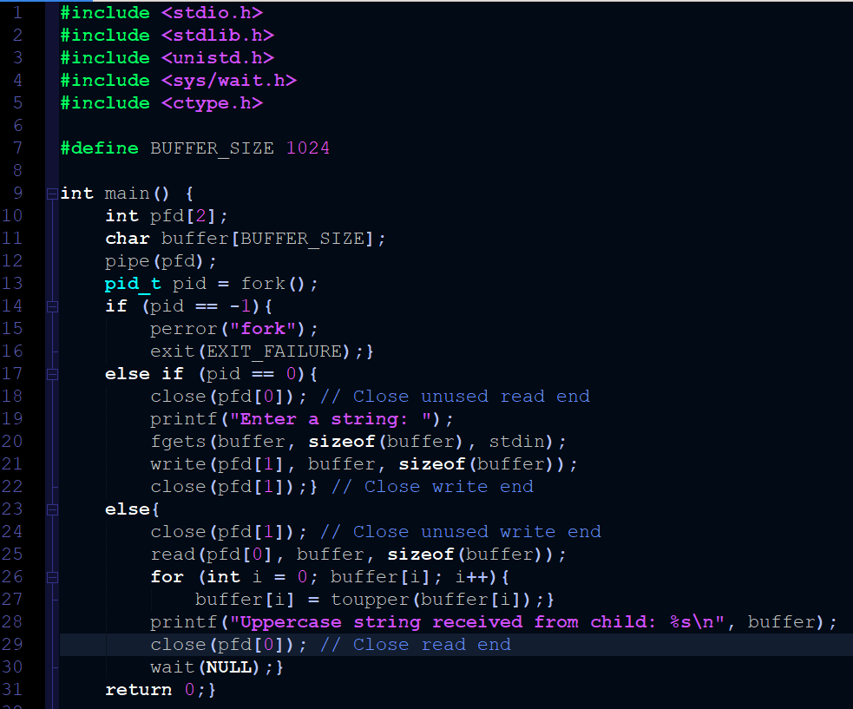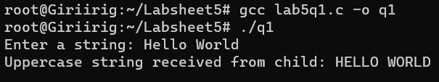

1. **Write a C Program that allows communication between parent and child process using ordinary PIPES. The parent should keep on taking integers from the user and supplying it to child until a special character is encountered. The child should display the sum of these numbers.**

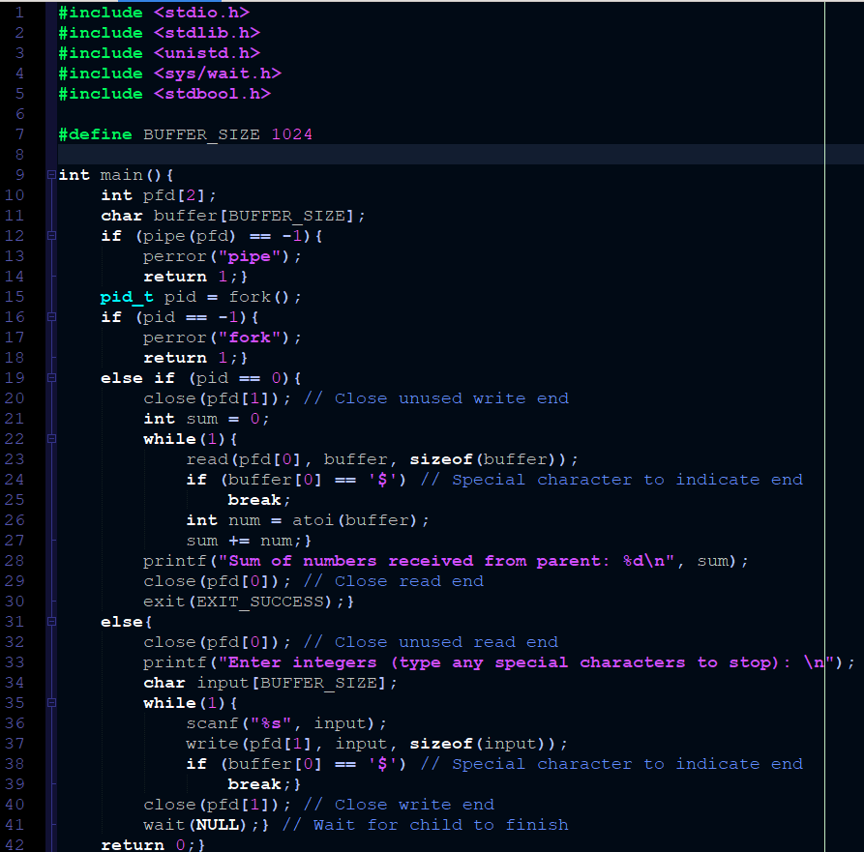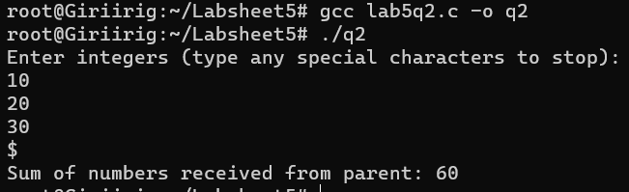

1. **Write a c program using pipes to find average of square of numbers supplied by a user using 3 processes. 1 parent and two children.** 
   1. **Parent should continuously take integers as input from the user until a special character, square it and supply it to both children.**
   2. **Child #1 should find sum of these numbers, send it to the parent and exit.**
   3. **Child #2 should count these numbers, send them to the parent, and exit d.  Parent on getting response from both the children should find mean of square of numbers supplied by the user by dividing the child #1's result with child 2's and give it to the user**

#include <stdio.h>

#include <stdlib.h>

#include <unistd.h>

#include <sys/wait.h>

int main() {

    int pc1[2], pc2[2], cp1[2], cp2[2];

    if (pipe(pc1) == -1 || pipe(pc2) == -1 || pipe(cp1) == -1 || pipe(cp2) == -1){

        perror("pipe");

        return 1;}

    pid_t child1_pid, child2_pid;

    if ((child1_pid = fork()) == -1){

        perror("Fork failed");

        return 1;}

    if (child1_pid == 0){  // Child 1 process

        close(pc1[1]);

        close(cp1[0]);

        close(pc2[0]);

        close(pc2[1]);

        close(cp2[0]);

        close(cp2[1]);

        int sum = 0, num;

        while (read(pc1[0], &num, sizeof(int)) > 0){

            sum += num * num;}

        close(pc1[0]);

        write(cp1[1], &sum, sizeof(int));

        close(cp1[1]);

        exit(0);}

    else{  // Parent process

        if ((child2_pid = fork()) == -1){

            perror("Fork failed");

            return 1;}

        if (child2_pid == 0){  // Child 2 process

            close(pc1[0]);

            close(pc1[1]);

            close(cp1[0]);

            close(cp1[1]);

            close(pc2[1]);

            close(cp2[0]);

            int count = 0, num;

            while (read(pc2[0], &num, sizeof(int)) > 0){

                count++;}

            close(pc2[0]);

            write(cp2[1], &count, sizeof(int));

            close(cp2[1]);

            exit(0);

        }

        else{  // Parent process

            close(pc1[0]);

            close(pc2[0]);

            close(cp1[1]);

            close(cp2[1]);

            int num;

            printf("Enter integers: ");

            while (scanf("%d", &num) == 1) {

                write(pc1[1], &num, sizeof(int));

                write(pc2[1], &num, sizeof(int));}

            close(pc1[1]);

            close(pc2[1]);

            int sum, count;

            read(cp1[0], &sum, sizeof(int));

            read(cp2[0], &count, sizeof(int));

            close(cp1[0]);

            close(cp2[0]);

            if (count != 0){

                float mean = (float)sum / count;

                printf("Mean of squares: %.2f\n", mean);}

            else{

                printf("No numbers were entered.\n");}

            wait(NULL);

            wait(NULL);}

    }

    return 0;}

